Oil and Natural Gas Time Series Forecasting

Fran Poljak

Zagreb School of Economics and Management

Zagreb, Croatia

[fpoljak@student.zsem.hr](mailto:fpoljak@student.zsem.hr)

1. INTRODUCTION

In this seminar paper we will explore different time series forecasting methods using ARIMA, SARIMA and SARIMAX models. The focus will be on oil and natural gas as they are extremely important resources for European economies and constitute a large portion of demand and thus effectively predicting prices might help in policy making and reducing the overall energy dependence of the member states. Firstly, we will be explaining the nature of each prediction model and afterwards we will be evaluating oil and natural gas price time series data. Each of the models will be evaluated using accuracy metrics in the end and we will see which models perform the best on the given data and explain why the models behave in such way.

1. DATA SETS USED

The packages used in the seminar paper include pandas, to handle data frames, matplotlib, for plotting data, sklearn and statsmodels, to preform ARIMA and SARIMA models, and prophet package, also used as a time series prediction model. The data we used was primarily gathered from nasdaqdatalink, also a package which is used to gather time series data on stocks and commodities. For the natural gas price daily price data of natural gas futures is used with the period from 2000 until 2022. Oil price data used is OPEC crude oil price with daily frequency dating from 2000 until 2022. Oil and natural gas consumption were also used with frequency being monthly and the period from 2000 until 2020. Furthermore, datasets contain only the data on prices and dates.

1. PREDICTION MODELS

As already mentioned, this seminar paper will focus on exploring different time series forecasting models like ARIMA, SARIMA, SARIMAX and the Meta’s Prophet model. In this chapter we will explain some theory of each model and try to understand how they work.

* 1. ARIMA AND SARIMA

ARIMA model or autoregressive integrated moving average is a model that uses historical data and its performance to forecast future values. Each model contains parameters as entries in the model. ARIMA (p, d, q) contains three parameters, *p,* being the number of lags in the model, *d*, number of times we differenced the original time series, and *q*, which is the order of MA, or the moving average. Differencing the time series is also an important factor since it is important to make the series stationary if not already, this will be explored further in coming chapters. Similarly, SARIMA model is no different from ARIMA model. The only and major difference is that uses seasonality as a factor. SARIMA model uses the number of seasons as the number of differencing required. SARIMA model is contains entries looking like following, *SARIMA (p, d, q) (P, D, Q)m*, with *m* being the seasonality factor, so for example, *m = 12,* meaning monthly data.

* 1. SARIMAX

SARIMAX model, like the ARIMA and SARIMA models contain the same parameters, the only difference is that it also adds exogenous variables. This leads us to the conclusion that SARIMAX models can be useful to predict future trends and the dependence of two seasonal datasets which also allows us to check the degree of their correlation.

* 1. PROPHET

Prophet algorithm on the other hand is a bit different, although we will not be going into specifics about the algorithm itself, we will briefly be explaining it in this chapter. Prophet is a time series forecasting method which is, according to Facebook, “based on additive model where non-linear trends are fit with yearly, weekly and daily seasonality, plus holiday effects”. [1] Also, as stated, the model is immune if some of the data is missing, trend shifts and “handles outliers well”. [1]

1. DATA MODELING

Now that we have briefly explained the models used in the seminar paper, we will continue with the actual modeling. Most of the modeling was done by replicating code from already existing projects and by using our own gathered datasets and time series.

* 1. ARIMA MODEL FOR OIL PRICES

Here we will show the process of creating the ARIMA model while also including some figures essential to the process. This ARIMA model was recreated using already existing code from the following source.[2] Firstly, let’s look at the model when imputing data on oil prices. Accordingly, ADF test tells us that if p-value is larger than 0.05 we must difference the series to make it stationary. We have differenced the series twice and will be taking the order of differencing as *d = 1,* secondly from the partial autocorrelation, further PACF, we conclude the AR term, or the *p* term to be *p = 1,* finally the MA term or the order of q will be *q = 1.* Now to the actual model, as parameters indicate we create the ARIMA (1, 1, 1) model which also gives us the best result from our data and from plotting the residuals in Fig. 1. we can see that the model fits well although when plotting the out of time cross validation of our model in Fig. 2. where we see the actual forecast, is not so good in the end.

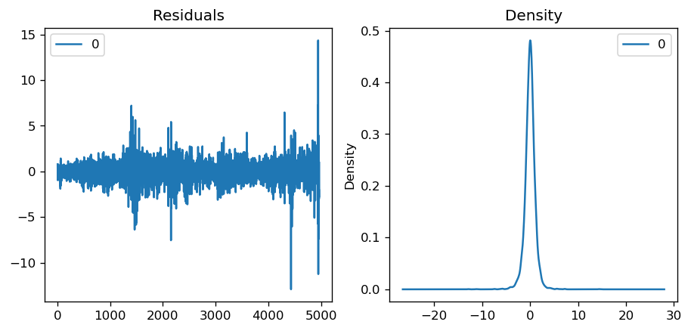

Fig. 1. Residual Plot ARIMA Oil Prices

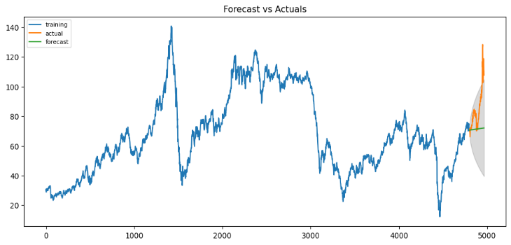

Fig. 2. Forecast Plot, ARIMA Oil Prices

As we already mentioned, when looking at the residual plot we can see that the model should be good, but when looking at the actual forecast plot we can see that the model is not that efficient in predicting the trend. The accuracy metric, MAPE, tells us that our model is about 85.7% accurate in predicting the next 15 observations. Next, we have also run the auto ARIMA which automatically detects the best suitable order of our model. The results of the residual plots can be seen in Fig. 3. and Fig. 4.

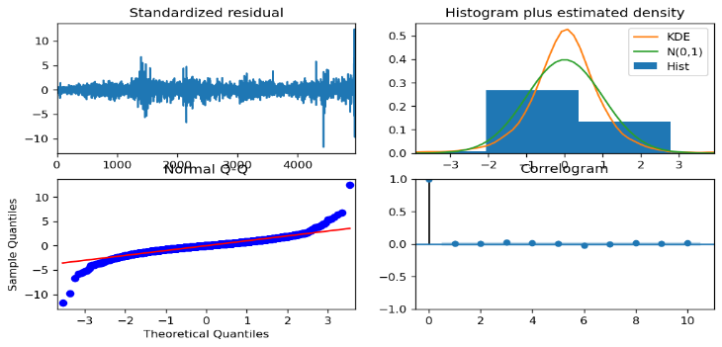

Fig. 3. Residual Plot, Auto ARIMA Oil Prices

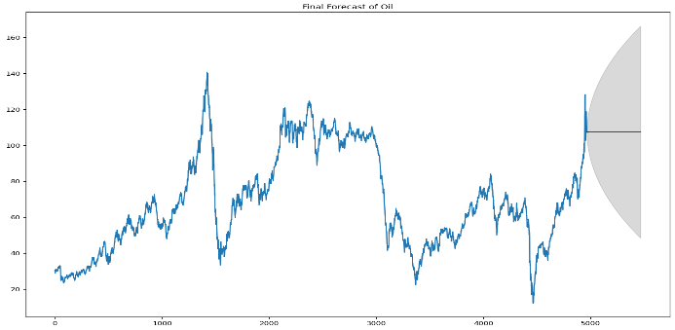

Fig. 4. Forecast Plot, Auto ARIMA Oil Price

From the residual plot we can see that our model is somewhat good but from the actual forecast plot again we can see that our model is not so efficient.

* 1. ARIMA MODEL FOR NATURAL GAS PRICE

In this chapter we will be repeating the analysis we did before only on a different dataset. This time we will be using natural gas prices as our dataset. This code is also extracted from the same source as stated above and replicated using collected data.[2] The ADF test conducted on this series indicated p-value being smaller than 0.05 but we end up differencing the series anyway for the purposes of demonstration. The parameters for our ARIMA model this time will be ARIMA (1, 2, 2) as this model outputs p-values that indicate significancy. When looking at residual plot and the out of time cross validation plot for the forecast in Fig 5. and Fig. 6. Respectively, we can see that residuals again show promising results as they move around the mean value but the model, although better than the previous one, still falls short.

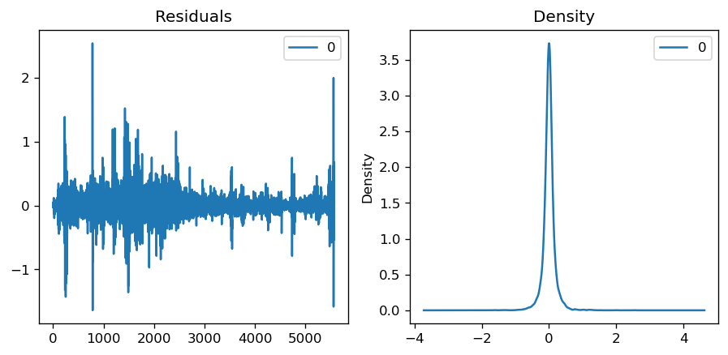

Fig. 5. Residual Plot, ARIMA Natural Gas

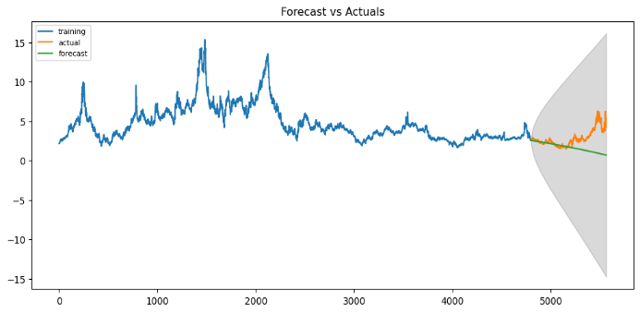

Fig. 6. Forecast Plot, ARIMA Natural Gas

Our accuracy metric, MAPE, this time tells us that our model is only about 67% accurate which is not good. Further, we have also done the auto ARIMA which as a result gave us that the best model is ARIMA (3, 0, 3).

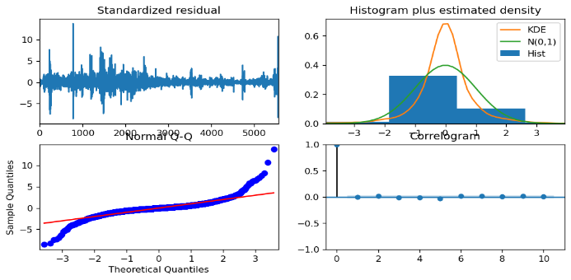

Fig. 7. Residual Plot, Auto ARIMA Natural Gas

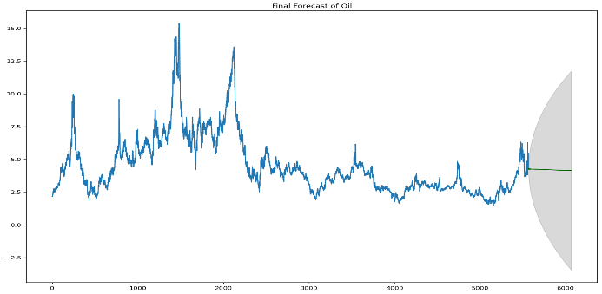

Fig. 8. Forecast Plot, Auto ARIMA Natural Gas

From the Fig. 7. And Fig. 8. We can see the residual plot and the forecast plot of the auto ARIMA model. The residual plot also looks good, albeit to a lesser degree while the forecast plot again falls short but manages to predict the initial falling trend in the beginning.

* 1. SARIMA MODEL FOR MONTHLY OIL PRICE

In this chapter we will be going through the SARIMA model using monthly oil price data. [2] As already mentioned, SARIMA model is essentially ARIMA with the addition of the seasonal factor. Firstly, we did the differencing of the time series which made the series stationary, and in Fig. 9. We can see the two different differencing done, seasonal and ordinary differencing.

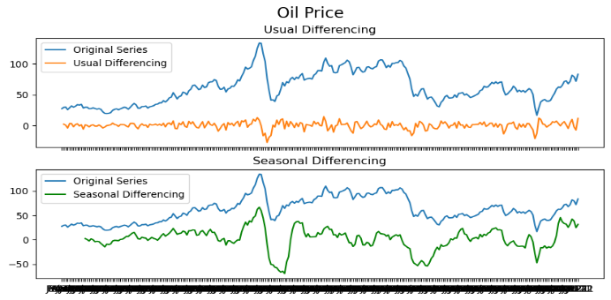

Fig. 9. Differencing Plot, SARIMA Monthly Oil Price

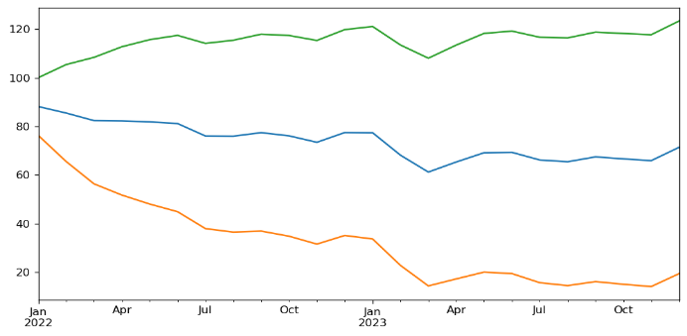

Fig. 10. Forecast Plot, SARIMA Monthly Oil Price

Finally, we have again run the auto SARIMA model which tells us that the best model should be SARIMAX (2, 0, 0) x (2, 1, 0, 12) and in the plot Fig. 10. We can see the upper and lower boundary of our forecast with the blue line indicating the forecast line. From the p-values we are getting from the model we can conclude that all the components are significant but again from the forecast we see that the model falls short.

* 1. PROPHET USING OIL AND NATURAL GAS PRICE

While in the previous chapters we explained and showed examples of ARIMA and SARIMA models, here we will be diving into another interesting time series forecasting model, and that is Facebooks Prophet model. Using prophet is straight forward with the only requirement being importing the and renaming the columns of the data, while all else is done by the model. In Fig. 11. we see prediction model made by the prophet algorithm.

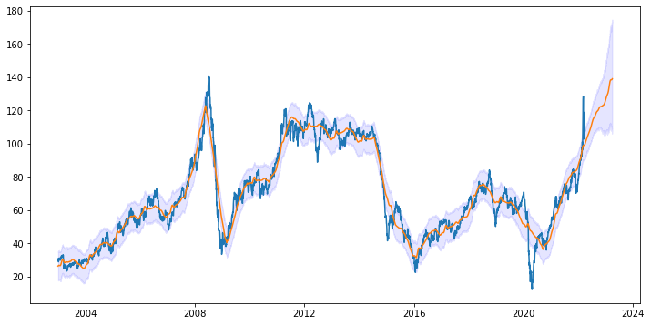

Fig. 11. Forecast Plot, PROPHET Oil Price

From Fig. 11. we can see that the prophet algorighm is not that good at following the original time series but we can see that it gives a better forecast than the previously mentioned ARIMA and SARIMAX models. The same principle was used using natural gas prices dataset. In Fig. 12. we can see the forecast plot which again seems to give a fairly good prediction of the price.

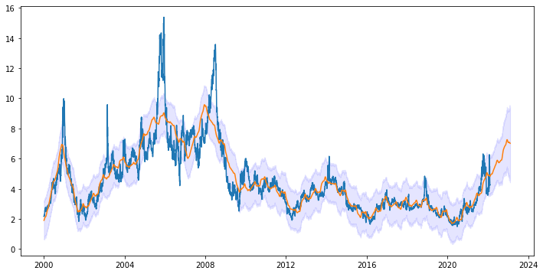

Fig. 12. Forecast Plot, PROPHET Natural Gas Price

Fig. 13. Changepoints Plot, Oil Price

Fig. 14. Changepoints Plot, Natural Gas Price

From figures above, namely Fig. 13. and Fig. 14. we can see changepoint graphs which illustrate trend changes in the data. The sharp decreasing which is followed by an increasing trend is visible in the periods of big crisis, like the 2008 crisis, and currently with the onset of the COVID-19 pandemic where we see a decreasing trend and also now with the beggining of Ukraine war crisis we see a sharp increase.

1. CONCLUSION

When forecasting natural gas and oil price data using ARIMA and SARIMA models we can see that the residual plots obtained tell us that the models should be doing well in forecasting future values to a certain degree. ARIMA and SARIMA models fall short when looking at the final forecast figures and, in the end, this can also be seen from very low numbers in accuracy tests with MAPE resulting in 85.7% and 67% respectively which are by no means high accuracy test scores. PROPHET algorithm on the other hand forecasts the trend better but fall short when following the original time series. When it comes to long and short-term forecasting the models fall short of forecasting accurate values in the long term. As for the short term the models are somewhat accurate in forecasting the overall trend of the data but never seem to give close values. This can be due to a number of factors. Our data on oil and natural gas does not exhibit cyclical behavior, but it rather moves in a random way. Furthermore, the movement in the time series data is highly dependent on “black swan” events such as the COVID-19 pandemic and the recent onset of the Ukraine war which cannot be predicted accurately and cause large disturbances in the data and a lot of outliers which we also saw from residual plots. Considering the aforementioned, the models can better be explored using different data, which, as we already stated, exhibits cyclical behavior and is not so outlier dense.

# REFERENCES

[1] <https://facebook.github.io/prophet/>

[2] <https://www.machinelearningplus.com/time-series/arima-model-time-series-forecasting-python/>

[3] <https://towardsdatascience.com/time-series-analysis-with-facebook-prophet-how-it-works-and-how-to-use-it-f15ecf2c0e3a>

[4] <https://github.com/swapkh91/Time-Series-Forecasting/blob/master/arima_confidence_interval.ipynb>